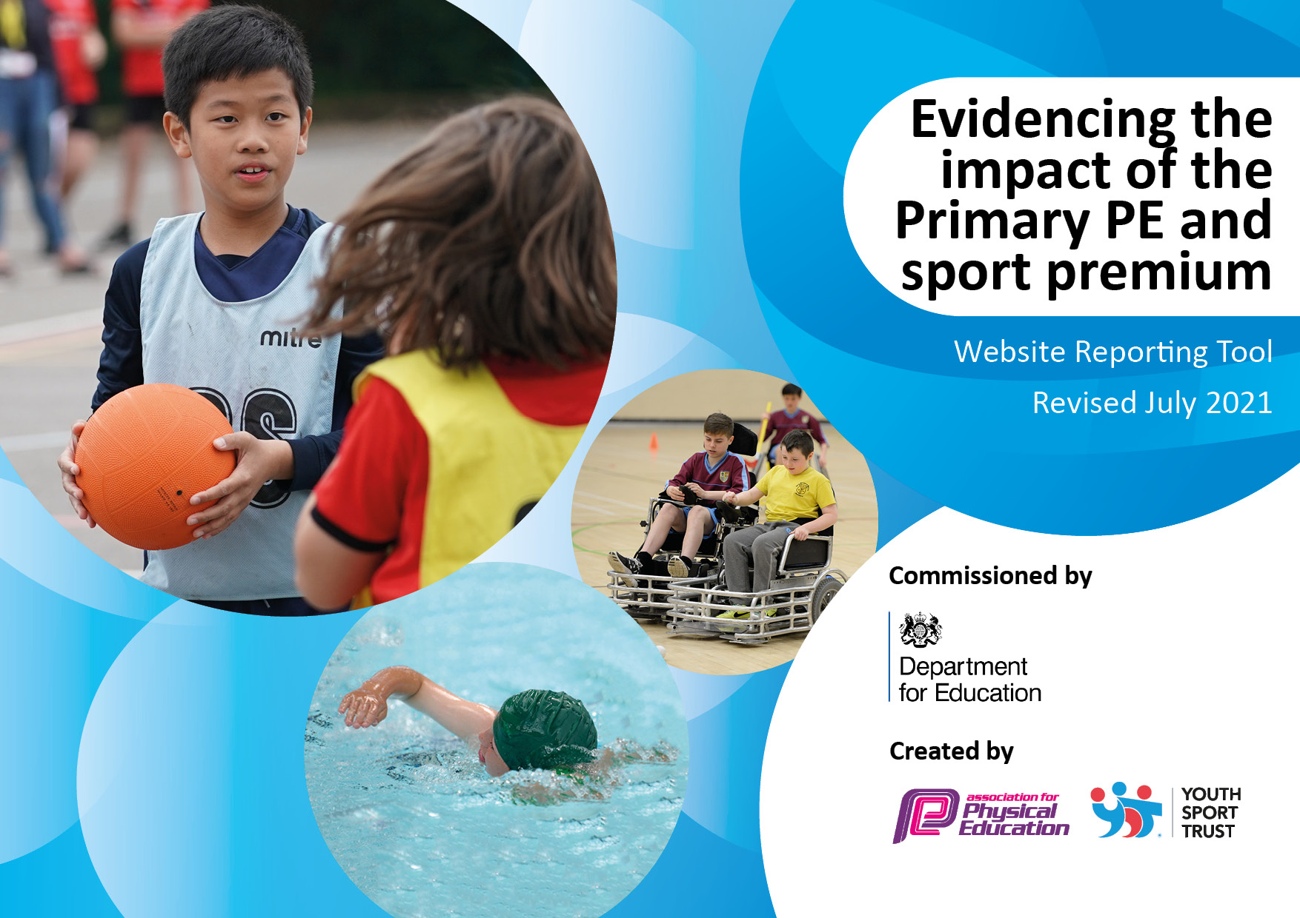
2022-2023
*Awaiting New Template
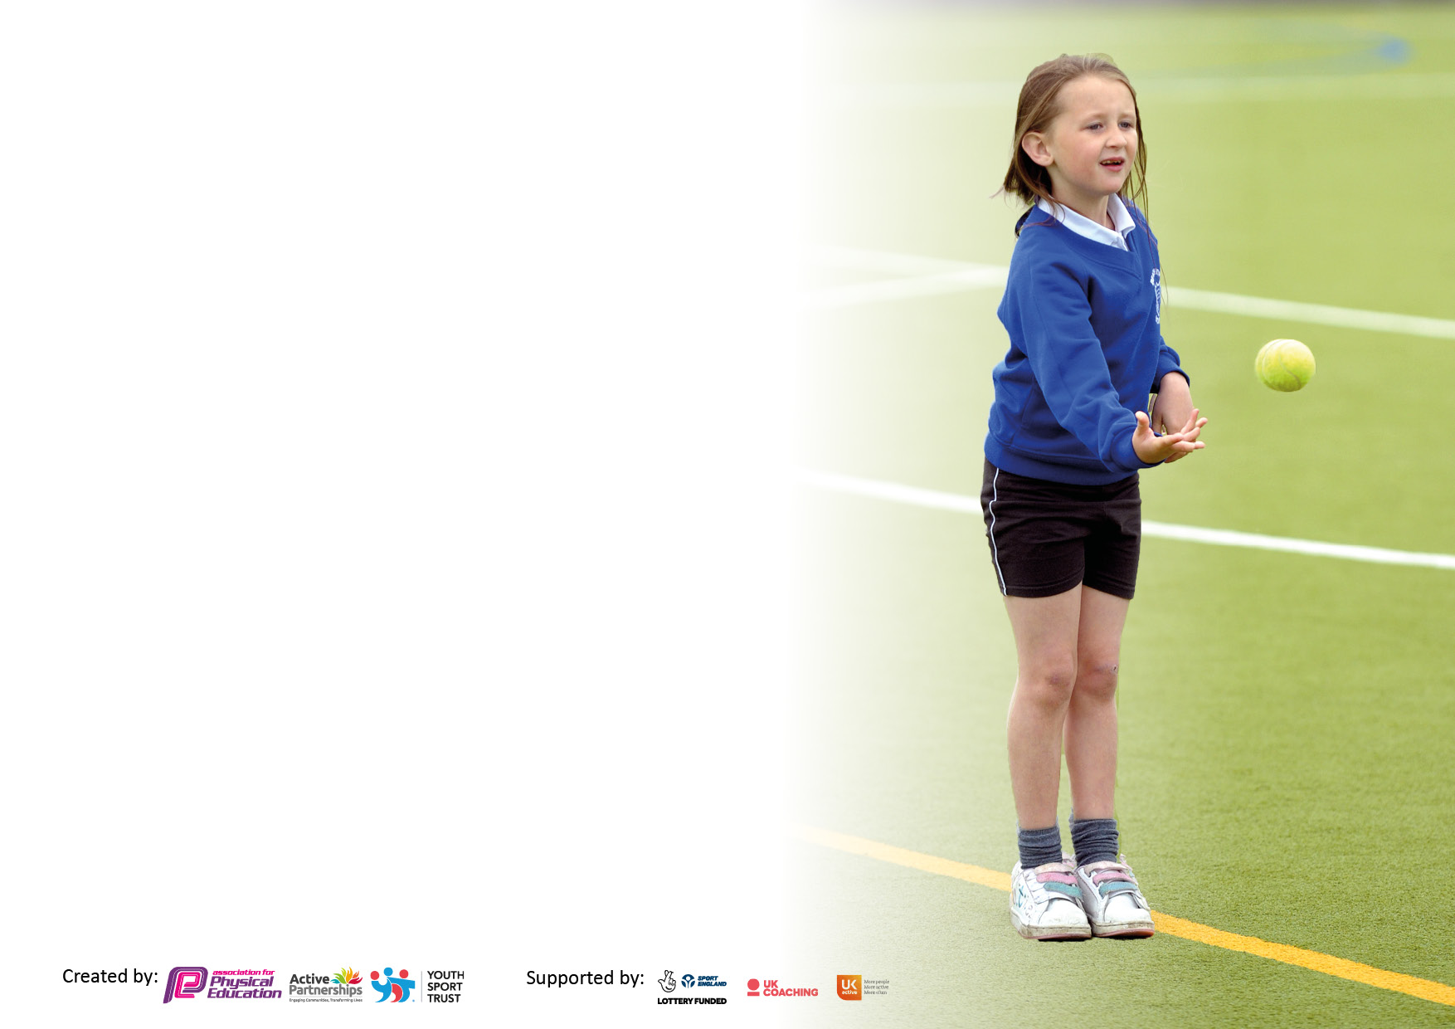

It is important that your grant is used effectively and based on school need. The Education Inspection Framework makes clear there will be a focus on ‘whether leaders and those responsible for governors all understand their respective roles and perform these in a way that enhances the effectiveness of the school’.

Under the Quality of Education Ofsted inspectors consider:
Intent - Curriculum design, coverage and appropriateness
Implementation - Curriculum delivery, Teaching (pedagogy) and Assessment
Impact - Attainment and progress

To assist schools with common transferable language this template has been developed to utilise the same three headings which should make your plans easily transferable between working documents.

Schools must use the funding to make additional and sustainable improvements to the quality of Physical Education, School Sport and Physical Activity (PESSPA) they offer. This means that you should use the Primary PE and sport premium to:

- Develop or add to the PESSPA activities that your school already offer
- Build capacity and capability within the school to ensure that improvements made now will benefit pupils joining the school in future years
- The Primary PE and sport premium should not be used to fund capital spend projects; the school’s budget should fund these.

Please visit gov.uk for the revised DfE guidance includingthe5keyindicatorsacrosswhichschoolsshoulddemonstrate animprovement.Thisdocumentwillhelpyoutoreviewyourprovisionandtoreportyourspend.DfEencouragesschools to use this template as an effective way of meeting the reporting requirements of the Primary PE and sport premium.

We recommend you start by reflecting on the impact of current provision and reviewing the previous spend.

Schools are required to publish details of how they spend this funding, including any under-spend from 2021/2022, as well as on the impact it has on pupils’ PE and sport participation and attainment. All funding must be spent by 31st July 2022.

We recommend regularly updating the table and publishing it on your website throughout the year. This evidences your ongoing self-evaluation of how you are using the funding to secure maximum, sustainable impact. Final copy must be posted on your website by the end of the academic year and no later than the 31st July 2021. To see an example of how to complete the table please click HERE.

Details with regard to funding
Please complete the table below.

Total amount allocated for 2022/23 | £17,750
How much (if any) do you intend to carry over from this total fund into 2021/22? | £0
Total amount allocated for 2022/23 | £17,750
Swimming Data
Please report on your Swimming Data below.

Meeting national curriculum requirements for swimming and water safety.

N.B. Complete this section to your best ability. For example, you might have practised safe self-rescue techniques on dry land which you can then transfer to the pool when school swimming restarts.
Due to exceptional circumstances, priority should be given to ensuring that pupils can perform safe self rescue even if they do not fully meet the first two requirements of the NC programme of study.
What percentage of your current Year 6 cohort swim competently, confidently and proficiently over a distance of at least 25 metres? | 86%
What percentage of your current Year 6 cohort use a range of strokes effectively [for example, front crawl, backstroke and breaststroke]?  Please see note above | 86%
What percentage of your current Year 6 cohort perform safe self-rescue in different water-based situations? | 86%
Schools can choose to use the Primary PE and sport premium to provide additional provision for swimming but this must be for activity over and above the national curriculum requirements. Have you used it in this way? | No

Action Plan and Budget Tracking
Capture your intended annual spend against the 5 key indicators. Clarify the success criteria and evidence of impact that you intend to measure to evaluate for pupils today and for the future.

Academic Year: 2022/23 | Total fund allocated: £17,750 | Date Updated: September 2022
Key indicator 1: The engagement of all pupils in regular physical activity – Chief Medical Officers guidelines recommend that primary school pupils undertake at least 30 minutes of physical activity a day in school |  |  |  | Percentage of total allocation:
 |  |  |  | 34%
Intent | Implementation |  | Intended Impact (July 2023)
Your school focus should be clear what you want the pupils to know and be able to do and about  what they need to learn and to  consolidate through practice: | Make sure your actions to achieve are linked to your intentions: | Funding allocated  £6000 | Evidence of impact: what do pupils now know and what can they now do? What has changed?: | Sustainability and suggested next steps:
Regular access to before/after school clubs and lunchtime activities which promote increased levels of fitness, improved wellbeing and teach about nutrition and diet.  Improvement in pupil wellbeing by developing an understanding of health lifestyle and mental health.  Improve levels of activity during lunchtimes for select pupils. | Expert Coaches from Aspire academy deliver the following provision each week:  - 3 hours of lunch clubs  - 3 hours of after school club (to include Reception-aged children)  Key children targeted for participation based on activity levels, NHS data and observation of physical fitness in P.E. lessons.  Well-being week to be held for children and families during the spring term (including use of external providers, e.g. ‘Relax Kids’)  Additional 1:6 ratio sports coaching for targeted children, including disadvantaged boys, children with behavioural needs and Post-LAC. | £6000
Key indicator 2: The profile of PESSPA being raised across the school as a tool for whole school improvement |  |  |  | Percentage of total allocation:
 |  |  |  | 30%
Intent | Implementation |  | Intended Impact (July 2023)
Your school focus should be clear what you want the pupils to know and be able to do and about  what they need to learn and to  consolidate through practice: | Make sure your actions to achieve are linked to your intentions: | Funding allocated£5410 | Evidence of impact: what do pupils now know and what can they now do? What has changed?: | Sustainability and suggested next steps:
Continue the commitment of 2 hrs of curriculum PE for all pupils. Develop leadership, learning and teaching of Physical Education so that all children make good or better progress.  Pupils develop expert knowledge about a wide range of games and activities and perform with high levels of expertise/skill | Further develop the teaching of P.E. through Aspire PECS development programme, support 4 staff per term, leading to sustainable improvement in the delivery of P.E.  P.E. lead to attend national conference for the leadership and development of P.E., in conjunction with Aspire. This will lead to improved leadership of P.E across school  Review and refine schemes of work to ensure teaching of a broader range of skills. Purchase quality schemes of work from ‘Get Set 4 P.E.’ so that staff are proficient in their delivery of P.E. | £4800  £60  £550

Key indicator 3: Increased confidence, knowledge and skills of all staff in teaching PE and sport |  |  |  | Percentage of total allocation:
 |  |  |  | As Key Indicator 1
Intent | Implementation |  | Intended Impact (July 2023)
Your school focus should be clear | Make sure your actions to | Funding | Evidence of impact: what do | Sustainability and suggested
what you want the pupils to know | achieve are linked to your | allocated: | pupils now know and what | next steps:
and be able to do and about | intentions: |  | can they now do? What has
what they need to learn and to |  |  | changed?:
consolidate through practice:
To move all P.E. teaching from ‘good to ‘outstanding’  Giving children a wide and varied PE & Sport Curriculum. | Use of specialist PE & Sports Instructors.  Ongoing CPD for all staff  Sports Coaches supporting staff in delivery of sports Curriculum | Aspire/P.E. Leadership (as above)
Key indicator 4: Broader experience of a range of sports and activities offered to all pupils |  |  |  | Percentage of total allocation:
 |  |  |  | 30%
Intent | Implementation |  | Intended Impact (July 2023)
Your school focus should be clear | Make sure your actions to | Funding | Evidence of impact: what do | Sustainability and suggested
what you want the pupils to know | achieve are linked to your | allocated: | pupils now know and what | next steps:
and be able to do and about | intentions: | £5340 | can they now do? What has
what they need to learn and to |  |  | changed?:
consolidate through practice:
Equipment audit and purchasing of equipment to ensure high quality provision and widening of sports offer in P.E. lessons (e.g. tennis equipment) | Sports lead to audit and order new equipment to ensure the curriculum offer of sports extends beyond the core curriculum aims.  Purchasing additional resources for specific use in EYFS to develop Gross Motor skills. | £3000  £2340

Key indicator 5: Increased participation in competitive sport |  |  |  | Percentage of total allocation:
 |  |  |  | 6%
Intent | Implementation |  | Intended Impact (July 2023)
Your school focus should be clear | Make sure your actions to | Funding | Evidence of impact: what do | Sustainability and suggested
what you want the pupils to know | achieve are linked to your | allocated: | pupils now know and what | next steps:
and be able to do and about | intentions: |  | can they now do? What has
what they need to learn and to |  | £1000 | changed?:
consolidate through practice:
All children to have opportunity to play team games for their school and their house teams.  Children participate in competitive games in the local/wider area and with a broad range of organisations. | Sports Lead/Aspire to focus on developing a programme of extended provision aimed around competitive sports.  Transport to and from sports venues and competitive fixtures. | N/A  £1000

Signed off by
Head Teacher: | Stuart Day
Date: | 15.9.22
Governor: | Anna Balson (Director of Education)
Date: | 15.9.22

