Anti-Bullying & Interventions
Policy

Date Policy Last Reviewed: January 2022

Contents:
Statement of intent
- Legal framework
- Definitions
- Types of bullying
- Roles and responsibilities
- Statutory implications
- Prevention
- Signs of bullying
- Staff principles
- Peer-on-peer abuse
- Cyberbullying
- Procedures
- Sanctions
- Support
- Follow-up support
- Bullying outside of school
- Record keeping
- Monitoring and review

Appendices
Appendix 1: Levels of Intervention
Appendix 2: Intervention Tables
Appendix 3: Level Intervention Activities/Scripts
Statement of intent
Brookvale Primary School believes that all pupils are entitled to learn in a safe and supportive environment; this means being free from all forms of bullying behaviour. This policy outlines how instances of bullying are dealt with, including the procedures to prevent occurrences of bullying.
These strategies, such as learning about tolerance and difference as part of the school’s curriculum, aim to promote an inclusive, tolerant and supportive ethos at the school.
The Education and Inspections Act 2006 outlines several legal obligations regarding the school’s response to bullying. Under section 89, schools must have measures in place to encourage good behaviour and prevent all forms of bullying amongst pupils. These measures are part of the school’s Behavioural Procedure, which is communicated to all pupils, school staff and parents.
All staff, parents and pupils work together to prevent and reduce any instances of bullying at the school. There is a zero-tolerance policy for bullying at the school.

Legal framework
This policy has due regard to all relevant legislation and statutory guidance including, but not limited to, the following:
- Education and Inspections Act 2006
- Equality Act 2010
- Protection from Harassment Act 1997
- Malicious Communications Act 1988
- Public Order Act 1986
- Communications Act 2003
- Human Rights Act 1998
- Crime and Disorder Act 1998
- Education Act 2011
- DfE (2017) ‘Preventing and tackling bullying’
- DfE (2021) ‘Sexual violence and sexual harassment between children in schools and colleges’
- DfE (2018) ‘Mental health and wellbeing provision in schools’
- DfE (2021) ‘Keeping children safe in education 2021’
- DfE (2020) ‘Sharing nudes and semi-nudes: advice for education settings working with children and young people’

This policy operates in conjunction with the following school policies:
- Behavioural Procedure
- Safeguarding Policy and Child Protection Policy
- Primary Relationships and Health Education Policy
- Exclusion Policy

Definitions
Although there is not a legal definition for ‘bullying’, for the purpose of this policy, “bullying” is defined as persistent behaviour by an individual or group with the intention of verbally, physically, or emotionally harming another person or group. Bullying is generally characterised by:
- Repetition: Incidents are not one-offs; they are frequent and happen over an extended period of time.
- Intent: The child who is bullying means to cause verbal, physical or emotional harm; it is not accidental.
- Targeting: Bullying is generally targeted at a specific individual or group.
- Power imbalance: Whether real or perceived, bullying is generally based on unequal power relations.

Vulnerable pupils are more likely to be the targets of bullying due to the attitudes and behaviours some young people have towards those who are different from themselves. Vulnerable pupils may include, but are not limited to:
- Pupils who are adopted.
- Pupils suffering from a health problem.
- Pupils with caring responsibilities.
- Pupils from socio-economically disadvantaged backgrounds.

Pupils with certain characteristics are also more likely to be targets of bullying, including, but not limited to:
- Pupils who are LGBTQ+, or perceived to be LGBTQ+.
- Black, Asian and minority ethnic (BAME) pupils.
- Pupils with SEND.

Staff at Brookvale Primary School recognise that there must be a separation between the behaviour a pupil is demonstrating and the pupil themselves. Staff are therefore encouraged to describing situations, e.g. ‘a bullying incident was reported on 20/01/22 where Child XX is alleged to have displayed racist bullying behaviour towards Child YY.’

‘Victim’: The term victim is problematic – it can mean different things to different people. Because of this, staff at Brookvale Primary School use the term ‘child who has been bullied’, or ‘target of bullying’.

‘Bully’: The term bully is problematic – it implies focus on the child’s self, rather than the behaviour he or she is displaying. Because of this, staff at Brookvale Primary School use the term ‘child who is displaying bullying behaviour’

Types of bullying
Many kinds of behaviour can be considered bullying, and bullying can be related to almost anything. Teasing another pupil because of their appearance, religion, ethnicity, gender, sexual orientation, home life, culture, or SEND are some of the types of bullying that can occur.
Bullying is acted out through the following mediums:
- Verbal
- Physical
- Emotional
- Online (cyberbullying)

Racist bullying: Bullying another person based on their ethnic background or skin colour. Racist bullying is a criminal offence under the Crime and Disorder Act 1998 and Public Order Act 1986.
Homophobic and biphobic bullying: Bullying another person because of their actual or perceived sexual orientation.
Transphobic bullying: Bullying based on another person’s gender identity or gender presentation, or for not conforming to dominant gender roles.
Sexist bullying: Bullying based on sexist attitudes expressed in a way to demean, intimidate or harm another person because of their sex or gender. Sexist bullying may sometimes be characterised by inappropriate sexual behaviours.
Sexual bullying: Bullying behaviour that has a physical, psychological, verbal or non-verbal sexual dimension or dynamic that subordinates, humiliates or intimidates another person. This is commonly underpinned by sexist attitudes or gender stereotypes.
Ableist bullying: Bullying behaviour that focusses on another person’s disability or support needs; this can include mocking the individual’s disability or their needs, using derogatory words or slurs in relation to an individual’s disability, or deliberately excluding an individual because of their disability.
Prejudicial bullying: Bullying based on prejudices directed towards specific characteristics or experiences, e.g. religion or mental health issues.
Relational bullying: Bullying that primarily constitutes of excluding, isolating and ostracising someone – usually through verbal and emotional bullying.
Socio-economic bullying: Bullying based on prejudices against the perceived social status of the victim, including, but not limited to, their economic status, their parents’ occupations, their health or nutrition level, or the perceived “quality” of their clothing or belongings.

Roles and responsibilities
The Trust Governing Board is responsible for:
- Evaluating and reviewing this policy to ensure that it does not discriminate against any pupils on the basis of their protected characteristics or backgrounds.
- The overall implementation and monitoring of this policy.
- Ensuring that the school adopts a tolerant and open-minded policy towards difference.
- Ensuring the school is inclusive.
- Analysing any bullying data to establish patterns and reviewing this policy in light of these.
- Appointing a safeguarding link governor who will work with Head Teacher/DSL to ensure the policies and practices relating to safeguarding, including the prevention of cyberbullying, are being implemented effectively.

The Head Teacher is responsible for:
- Reviewing and amending this policy, accounting for new legislation and government guidance, and using staff experience of dealing with bullying incidents in previous years to improve procedures.
- Keeping a record of all reported incidents, including which type of bullying has occurred, to allow for proper analysis of the data collected.
- Analysing the data in the bullying record at termly intervals to identify trends, so that appropriate measures to tackle them can be implemented.
- Arranging appropriate training for staff members.

Senior Leaders are responsible for:
- Corresponding and meeting with parents where necessary.
- Providing a point of contact for pupils and parents when more serious bullying incidents occur.
- Investigating bullying allegations, as directed by the Head Teacher.
- Establishing interventions for the child that is bullying and the child that is being bullied and monitoring the impact of these.
- Evaluating trends and planning appropriate actions/staff CPD in conjunction with the Head Teacher.
- Ensuring staff enact the procedures outlined for investigating bullying.

Teachers are responsible for:
- Being alert to social dynamics in their class.
- Being available for pupils who wish to report bullying.
- Providing follow-up support after bullying incidents.
- Being alert to possible bullying situations, particularly exclusion from friendship groups, and informing the pupil’s heads of year of such observations.
- Refraining from stereotyping when dealing with bullying.
- Understanding the composition of pupil groups, showing sensitivity to those who have been the victims of bullying.
- Reporting any instances of bullying once they have been approached by a pupil for support and taking these seriously.
- Teaching a well-planned curriculum that challenges discriminatory behaviour; promotes tolerance, acceptance and shared understanding of keeping everyone safe; and actively discussing the negative impact of bullying.
- Providing ongoing support for the child being bullied and the child who is bullying.

Parents are responsible for:
- Informing their child’s teacher or senior leader if they have any concerns that their child is the victim of bullying or involved in bullying in anyway.
- Being watchful of their child’s behaviour, attitude and characteristics and informing the relevant staff members of any changes.

Pupils are responsible for:
- Informing a member of staff if they witness bullying or are a victim of bullying.
- Not making counter-threats if they are victims of bullying.
- Walking away from dangerous situations and avoiding involving other pupils in incidents.
- Keeping evidence of cyberbullying and informing a member of staff should they fall victim to cyberbullying.

Statutory implications
The school understands that, under the Equality Act 2010, it has a responsibility to:
- Eliminate unlawful discrimination, harassment, victimisation and any other conduct prohibited by the act.
- Advance equality of opportunity between people who share a protected characteristic and people who do not share it.
- Foster good relations between people who share a protected characteristic and people who do not share it.

The school understands that, under the Human Rights Act (HRA) 1998, it could have charges brought against it if it allows the rights of pupils to be breached by failing to take bullying seriously. The Head Teacher will ensure that this policy complies with the HRA; the Head Teacher understands that they cannot do this without fully involving their teaching staff.
Although bullying itself is not a criminal offence, some types of harassment, threatening behaviour and/or communications may be considered criminal offences:
- Under the Malicious Communications Act 1988, it is an offence for a person to electronically communicate with another person with the intent to cause distress or anxiety, or in a way which conveys a message which is indecent or grossly offensive, a threat, or contains information which is false and known or believed to be false by the sender.
- The Protection from Harassment Act 1997 makes it an offence to knowingly pursue any course of conduct amounting to harassment.
- Section 127 of the Communications Act 2003 makes it an offence to send, by means of a public electronic communications network, a message, or other matter, that is grossly offensive or of an indecent, obscene or menacing character. It is unlawful to disseminate defamatory information through any media, including internet sites.
- Other forms of bullying which are illegal and should be reported to the police include violence or assault, theft, repeated harassment or intimidation, and hate crimes.

Prevention
The school will clearly communicate a whole-school commitment to addressing bullying in the form of a written statement which will be regularly promoted across the whole school.
All members of the school will be made aware of this policy and their responsibilities in relation to it. All staff members will receive training on identifying and dealing with the different types of bullying.
All types of bullying will be discussed as part of the Relationships and Health Education curriculum, in line with the Primary Relationships and Health Education Policy; through circle times; class assemblies; guest speakers etc.
Staff will encourage pupil cooperation and the development of interpersonal skills using group and pair work. Diversity, difference and respect for others will be promoted and celebrated through various lessons. Opportunities to extend friendship groups and interactive skills will be provided through participation in special events, e.g. drama productions, sporting activities and cultural groups.
Seating plans will be organised and altered in a way that prevents instances of bullying. Potential victims of bullying will be placed in working groups with other pupils who do not abuse a perceived imbalance of power or take advantage of others.
Pupils deemed vulnerable, as defined in section two, will be monitored, where appropriate, to ensure any problems that arise can be actioned quickly. All staff across school will also offer an ‘open door’ policy allowing pupils to discuss any bullying, whether they are victims or have witnessed an incident. All pupils will be listened to and all allegations of bullying will be taken seriously.
Before a new pupil joins the school, particularly when this happens in-year, the pupil’s class teacher and the DSL will implement a strategy to prevent bullying from happening – this will include, but not limited to: whole class discussions with the receiving class based on themes of ‘new beginnings’ and acceptance of new people (including highlighting the challenges of attending a new school); a tour of the school and introduction to all staff so that the child can identify their ‘trusted adult; and a meeting with the Pastoral Lead to discuss what to do if they have any concerns/issues. Where a new pupil is deemed vulnerable, this strategy may involve further observation or intervention on the part of the DSL.
The school will be alert to, and address, any mental health and wellbeing issues amongst pupils, as these can be a cause, or a result, of bullying behaviour.
The school will ensure children who are demonstrating bullying behaviour are given support as required, so their educational, emotional and social development is not negatively influenced by outside factors, e.g. mental health issues, and that any underlying safeguarding concerns are identified.

Signs of bullying
Staff will be alert to the following signs that may indicate a pupil is being bullied:
- Being frightened to travel to or from school
- Unwillingness to attend school
- Repeated or persistent absence from school
- Becoming anxious or lacking confidence
- Saying that they feel ill repeatedly
- Decreased involvement in school work
- Leaving school with torn clothes or damaged possessions
- Missing possessions
- Missing dinner money
- Asking for extra money or stealing
- Cuts or bruises
- Lack of appetite
- Unwillingness to use the internet or mobile devices
- Lack of eye contact
- Becoming short tempered
- Change in behaviour and attitude at home

Although the signs outlined above may not be due to bullying, they may be due to deeper social, emotional or mental health issues, so are still worth investigating. Pupils who display a significant number of these signs will be approached by a member of staff to determine the underlying issues causing this behaviour.
Staff will be aware of the potential factors that may indicate a pupil is likely to exhibit bullying behaviours, including, but not limited to, the following:
- They have experienced mental health problems, which have led to them becoming more easily aggravated
- They have been the victim of abuse
- Their academic performance has started to fall and they are showing signs of stress

If staff become aware of any factors that could lead to bullying behaviours, they will notify a Senior Leader/ DSL who will investigate the matter and monitor the situation. All disclosures of bullying must be recorded on the child’s MyConcern log by the person in receipt of the disclosure. Staff should use principles of safeguarding all children and note any concerns as these build a comprehensive chronology for children through time.

Staff principles
The school will ensure that prevention is a prominent aspect of its anti-bullying vision.
Staff will treat reports of bullying extremely seriously and will not ignore signs of suspected bullying. Staff will act immediately when they become aware of a bullying incident. Unpleasantness from one pupil towards another will always be challenged and will never be ignored.
Staff will always respect pupils’ privacy, and information about specific instances of bullying should not be discussed with other children, unless the pupil has given consent. If a member of staff believes a pupil is in danger, e.g. of being hurt, they will inform the DSL immediately.
Follow-up support will be given to both the child who is being bullied and the child who is bullying in the days, weeks and months following an incident to ensure all bullying has stopped.
Staff must always have a zero-tolerance approach to bullying and not accept bullying behaviours because of a child’s personal characteristics or background.

Peer-on-peer abuse
The school has a zero-tolerance approach to all forms of peer-on-peer abuse, including sexual harassment and sexual violence.
To prevent peer-on-peer abuse and address the wider societal factors that can influence behaviour, the school will educate pupils about abuse, its forms, and the importance of discussing any concerns and respecting others through the curriculum, assemblies and Personal Development and Wellbeing (PDW) lessons, in line with the Prevention section of this policy.
All staff will be aware that pupils of any age and gender are capable of abusing their peers. Staff will take all instances of peer-on-peer abuse equally seriously regardless of the characteristics of the perpetrators or victims, will never tolerate abuse as “banter” or “part of growing up”, and will never justify sexual harassment, as this can foster a culture of unacceptable behaviours. Staff will also be aware that peer-on-peer abuse can be manifested in many ways, including: sexting, sexual harassment and assault, and hazing- or initiation-type violence.
Pupils will be made aware of how to raise concerns or make a report and how any reports will be handled – this includes the process for reporting concerns about friends or peers. If a pupil has been harmed, is in immediate danger or is at risk of harm, a referral may be made to Children’ Advice and Support Services (CASS – 0121 303 1888), where the DSL deems this appropriate in the circumstances.
The school’s Safeguarding and Child Protection Policy outlines the school’s stance on addressing peer-on-peer abuse, including sexual abuse, and the procedures in place will be adhered to if any instances are uncovered or disclosed. More information on the school’s approach to preventing and managing instances of peer-on-peer abuse can be found within the Safeguarding and Child Protection Policy.

Cyberbullying
Cyberbullying can take many forms and can go even further than face-to-face bullying by invading personal space and home life, and can target more than one person. It can also take place across age groups and target pupils, staff and others, and may take place inside school, within the wider community, at home or when travelling. It can sometimes draw bystanders into being accessories.
Cyberbullying can include the following:
- Threatening, intimidating or upsetting text messages
- Threatening or embarrassing pictures and video clips
- Disclosure of private sexual photographs or videos with the intent to cause distress
- Silent or abusive phone calls
- Using the victim’s phone to harass others, to make them think the victim is responsible
- Threatening or bullying emails, possibly sent using a pseudonym or someone else’s name
- Menacing or upsetting responses to someone in a chatroom
- Unpleasant messages sent via instant messaging
- Unpleasant or defamatory information posted to blogs, personal websites and social networking sites, e.g. Facebook

NB. The above list is not exhaustive, and cyberbullying may take other forms.
The school has a zero-tolerance approach to cyberbullying. The school views cyberbullying with the same severity as any other form of bullying and will follow the procedure set out in section 12 this policy if they become aware of any incidents.
All members of staff will receive training on an annual basis on the signs of cyberbullying, in order to identify pupils who may be experiencing issues and intervene effectively.
Many of the signs of cyberbullying will be similar to those found in the ‘Signs of bullying’ section of this policy; however, staff will be alert to the following signs that may indicate a pupil is being cyberbullied:
- Avoiding use of the computer
- Being on their phone routinely
- Becoming agitated when receiving calls or text messages

Staff will also be alert to the following signs which may indicate that a pupil is cyberbullying others:
- Avoiding using the computer or turning off the screen when someone is near
- Acting in a secretive manner when using the computer or mobile phone
- Spending excessive amounts of time on the computer or mobile phone
- Becoming upset or angry when the computer or mobile phone is taken away

Parents will receive regular updates from National Online Safety (nationalonlinesafety.com) in order to educate them on the signs and symptoms of cyberbullying, and will be advised to report to the Head Teacher if their child displays any of the signs outlined in this section.
Staff will be aware that a cyberbullying incident might include features different to other forms of bullying, prompting a particular response. Significant differences may include the following:
- Possible extensive scale and scope – pupils may be bullied on multiple platforms and using multiple different methods that are made possible by virtue of the bullying taking place online
- The anytime and anywhere nature of cyberbullying – pupils may not have an escape from the torment when they are at home due to the bullying continuing through technology at all times
- The person being bullied might not know who the perpetrator is – it is easy for individuals to remain anonymous online and on social media, and pupils may be bullied by someone who is concealing their own identity
- The perpetrator might not realise that their actions are bullying – sometimes, the culture of social media, and the inability to see the impact that words are having on someone, may lead to pupils crossing boundaries without realising
- The victim of the bullying may have evidence of what has happened – pupils may have taken screenshots of bullying, or there may be a digital footprint that can identify the perpetrator.

The school will support pupils who have been victims of cyberbullying by holding formal and informal discussions with the pupil about their feelings and whether the bullying has stopped, in accordance with section 13 and section 14 of this policy.

Procedures for Addressing Allegations of Bullying
Minor incidents will be reported to the class teacher, who will investigate the incident, set appropriate sanctions for the child who is alleged of bullying, and inform a member of SLT of the incident and outcome. This should be recorded on the individual child’s MyConcern log and have ‘Associated People’ tagged.
Staff should adopt a positive mind set when responding to bullying concerns. They should be prepared with options for how to respond to incidents of bullying in a planned, deliberate and positive way. Confronting pupils who have bullied requires a high amount of self-control as well as preparation to know what to say and do. The following are important factors when managing a bullying situation.
- Be calm. It is important to be clear thinking and emotionally in control. Be positive. Have in mind the importance of maintaining a positive relationship with the pupil. A pupil is much more likely to modify his/her behaviour if he/she perceives that a teacher cares.
- Be assertive. Staff should directly and clearly express their thoughts, feelings and expectations concerning the need for the pupil to not only stop bullying, but also make restitution with the child who has been bullied.
- Be confident. It is important to trust that you will be successful in implementing practices that can have an impact on the pupil’s future behaviour. It is always helpful to focus on the behaviour, not the pupil.
- Ensure that the specific behaviour is in fact bullying behaviour which conforms to the school’s agreed definition of bullying as in the ‘Definitions’ section of this policy.
- Assess the situation and its severity level. Determine the appropriate level of response required to manage the situation effectively. Once the Incident Level has been determined, select one or more responses from the appropriate column(s) (see Appendix 1: Levels 1-4 Responses)
To determine level of severity, staff should take account of the following:
- The nature of the bullying behaviour- for example deliberate teasing, excluding or hitting. There is a tendency among those who have a duty of care to rate some bullying, particularly violence, as more serious than other subtle forms. This can be a dangerous mistake and leave us vulnerable to ignoring ‘teasing’ or ‘exclusion’.
- The frequency of the bullying behaviour: daily, weekly or less often.
- The duration of the bullying behaviour: whether over a short or prolonged period of time.
- The perceptions of the child being bullied – The seriousness of bullying can only be measured by the degree of distress suffered by the target.
When investigating a bullying incident, the following procedures will be adopted:
- The child who is being bullied, the alleged child who is doing the bullying and witnesses are all interviewed separately.
- Members of staff ensure that there is no possibility of contact between the pupils being interviewed, including electronic communication.
- If a pupil is injured, members of staff take the pupil immediately to a first aid trained staff member and the reason/extent of their injuries are recorded.
- A room is used that allows for privacy during interviews.
- A witness is used for serious incidents.
- If appropriate, the child alleged of bullying, the child being bullied and witnesses are asked to write down details of the incident; this may need prompting with questions from the member of staff to obtain the full picture.
- The Head Teacher will gather evidence of a cyberbullying incident; this may involve text messages, emails, photos, etc. provided by the victim.
- Premature assumptions are not to be made, as it is important not to be judgemental at this stage.
- Members of staff listen carefully to all accounts, being non-confrontational and not assigning blame until the investigation is complete. All questions should be asked in a neutral tone so that pupils communicate freely.
- All pupils involved are informed that they must not discuss the interview with other pupils.

Due to the potential for some specific forms of bullying to be characterised by inappropriate sexual behaviour, staff members involved in dealing with the incident are required to consider whether there is a need for safeguarding processes to be implemented.

Sanctions
If the Head Teacher is satisfied that bullying did take place, the child who is bullying will be helped to understand the consequences of their actions and warned that there must be no further incidents. The Head Teacher will inform them of the type of sanction to be used in this instance, e.g. loss of lunchtimes/breaktimes, privilege removal etc.
If possible, the Head Teacher will attempt reconciliation and will obtain an apology from the child who has been found to be bullying. This will either be in writing to the child who has been bullied, and/or witnesses if appropriate, or face-to-face, but only with the child who has been bullied full consent. Discretion will be used here; children who are subjected to bullying will never feel pressured into a face-to-face meeting with the child who has been bullying.
Parents are informed of bullying incidents and what action is being taken.
All staff involved in managing instances of bullying will be aware that taking disciplinary action and providing support are not mutually exclusive actions, and should be conducted simultaneously to encourage more positive behaviour in future.
The school’s focus when handling children are bullying others will be supporting them to develop more positive behaviours and to refrain from abusive and bullying behaviours in the future.
The Senior Leadership Team, Pastoral Lead and Head Teacher will informally monitor the pupils involved over the next half-term and immediately address any concerns, repeated behaviours.
The school will remain cognisant of the fact that continued access to school can be important for rehabilitation of harmful behaviour, and will not exclude pupils unless as a last resort – where there have been serious or consistent incidents of bullying, the school will act in line with the Exclusion Policy.

Support
In the event of bullying, children who have been bullied will be offered the following support:
- Emotional support and reassurance from the class teacher and Pastoral Leader.
- Reassurance that it was right to report the incident and that appropriate action will be taken.
- Liaison with their parents to ensure a continuous dialogue of support.
- Advice not to retaliate or reply, but to keep the evidence and show or give it to their parent or a member of staff.
- Advice on aspects of online safety, in the event of cyberbullying, to prevent re-occurrence, including, where appropriate, discussion with their parents to evaluate their online habits and age-appropriate advice on how the perpetrator might be blocked online.
- In a small number of cases, discussion with their parent on whether police action is required (except in serious cases of child exploitation or abuse where the police may be contacted without discussion with parents).

The Head Teacher will carefully consider in each instance of bullying that is handled whether it is appropriate to split up the child being bullied and the child doing the bullying, e.g. preventing them from sharing spaces or activities, and will split up other harmful group dynamics to prevent further occurrences where necessary. Children who are being bullied will be encouraged to broaden their friendship groups by joining lunchtime or after-school clubs or activities.
Staff, particularly the Pastoral Lead, will work with the pupil to build resilience, e.g. by offering emotional therapy.
The school will acknowledge that bullying may be an indication of underlying mental health issues. The school will evaluate each case individually and will seek external services where appropriate.

Follow-up support
The progress of both the child who is accused of bullying and the child being bullied will be monitored by their class teachers, Senior Leaders, Pastoral Lead and Head Teacher. One-on-one sessions to discuss the situation is progressing may be appropriate. If appropriate, follow-up correspondence will be arranged with parents after the incident.
Pupils who have been bullied will be offered continuous support. The Pastoral Lead/Senior Leadership Team regularly check in, to see whether the bullying has stopped – this will continue until school are confident the bullying has stopped. The child who is being bullied will be encouraged to tell a trusted adult in school if bullying is repeated.
Pupils who have bullied others will be supported in the following ways:
- Receiving a consequence for their actions
- Being able to discuss what happened
- Being helped to reflect on why they became involved
- Being helped to understand what they did wrong and why they need to change their behaviour
- Appropriate assistance from parents
- External agency involvement (e.g., counselling, therapeutic care, mental health referral etc.) where necessary.

Bullying outside of school
Staff will remain aware that bullying can happen both in and outside of school, and will ensure that they understand how to respond to reports of bullying that occurred outside school in line with the Safeguarding and Child Protection Policy.
The Head Teacher has a specific statutory power to discipline pupils for poor behaviour outside of the school premises. Section 89 (5) of the Education and Inspections Act 2006 gives the Head Teacher the power to regulate pupils’ conduct when they are not on school premises, and therefore, not under the lawful charge of a school staff member.
Teachers have the power to discipline pupils for misbehaving outside of the school premises. This can relate to any bullying incidents occurring anywhere off the school premises, such as on school or public transport, outside the local shops, or in a town or village centre.
Where bullying outside school is reported to school staff, it will be investigated and acted upon. In all cases of misbehaviour or bullying, members of staff can only discipline the pupil on school premises, or elsewhere when the pupil is under the lawful control of the member of staff, e.g. on a school trip.
The Head Teacher is responsible for determining whether it is appropriate to notify the police of the action taken against a pupil. If the misbehaviour could be of a criminal nature, or poses a serious threat to a member of the public, the police will be informed.

Record keeping
The DSL will ensure that robust records are kept with regard to all reported or otherwise uncovered incidents of bullying – this includes recording where decisions have been made, e.g. sanctions, support, escalation of a situation and resolutions.
The Head Teacher and DSLs will ensure that all decisions and actions recorded are reviewed on a regular basis for the purposes of:
- Identifying patterns of concerning, problematic or inappropriate behaviour on the part of certain pupils that may need to be handled, e.g. with pastoral support.
- Reflecting on whether cases could have been handled better and using these reflections to inform future practice.
- Considering whether there are wider cultural issues at play within the school, e.g. whether school culture facilitates discriminatory bullying by not adequately addressing instances, and planning to mitigate this.
- Considering whether prevention strategies could be strengthened based on any patterns in the cases that arise.

Monitoring and review
This policy is reviewed every two years by the Head Teacher. Any changes to this policy will be communicated to all relevant stakeholders.
The scheduled review date for this policy is January 2024.

Appendices

Appendix 1: Levels of Intervention

It is important to remember that every bullying incident should be individually assessed and an intervention chosen which best meets the individual pupil needs.

Whilst the suggestions below could be used as a helpful aide, they are not exhaustive in nature. Staff must use their professional discretion and knowledge of pupils involved to decide on an appropriate intervention, including any not listed below.

Level 1 Intervention - Low Level Bullying Behaviour

Interventions at Level 1 are to help individuals to recognise/reflect on their unacceptable behaviour and to “get them back on track” while listening to and supporting/strengthening the pupil(s) experiencing bullying. NEVER ignore low level bullying behaviour.

Staff should;
- Explain the inappropriateness of the behaviour in line with the school’s values.
- Identify possible consequences if the bullying behaviour continues.
- Point out the level of distress experienced by the bullied pupil.
- Help the bullied pupil to identify ways in which he/she may be strengthened and supported, e.g. peer support.
- Encourage reparation to be made, if appropriate.
- Monitor the situation carefully.
- Be prepared to intervene with a higher response level if the situation persists or deteriorates.
- Inform parents of both parties for transparency

Level 2 Interventions - Intermediate Level Bullying Behaviour

While interventions at Level 2 involve continuing with the above, there is shift from individual support to group interventions. To be effective small group work needs:
- The consent and involvement of the pupil being bullied.
- To be planned and timetabled, session length dependent on age and ability.
- Parental / carer consent and agreement from participating pupils.
- Carefully selected group membership.
- To take place in a suitable and comfortable environment.
- To be uninterrupted.
- To be facilitated in a positive manner, ideally by two adults whose roles may alternate allowing one to participate and one to observe.
- Structured and focused activities using active learning approaches to stimulate discussion and debate amongst members and develop group identity.
- Decision and outcomes to be agreed and recorded, e.g. on a flipchart.
- To facilitate the development of empathy amongst pupils.
- A solution focused approach to the situation. To provide opportunities for pupils to take responsibility.
- Regular meetings of the group.
- Regular meetings with the bullied pupil to assess ongoing effectiveness of agreed actions.
- To ensure regular feedback is given on agreed actions.

Level 3 Interventions - Complex Bullying Behaviour

Interventions at Level 3 will often involve the Pastoral Lead, SENCO, and other senior managers, in collaboration with pupil(s) and parents to determine the way forward in affecting change. Bullying at this level often involves complex group dynamics, where a number of roles are evident, such as those displaying bullying behaviour, bystanders and pupils experiencing bullying. Consequently, interventions may require one-to-one meetings, small group work and whole class involvement. These will often require group interventions as discussed in Level 2 along with individual support and strength building programmes.

Level 4 Interventions - High Risk Bullying Behaviour

Bullying behaviours assessed as Level 4 are severe and involve a significant threat to the safety and welfare of any or all of the pupils involved. Such severe bullying concerns may be new or may have proved resistant to earlier school interventions and have now been assessed as high risk. Incidents at this level must be assessed in relation to the risk posed to any/all of the pupils involved. As such, the school’s Child Protection policy and safeguarding procedures will need to be invoked. In addition to safeguarding procedures and practices including referral to external support services, the school’s interventions at Level 4 should continue to implement interventions detailed at Level 3 as appropriate.

Appendix 2: Intervention Tables
(Adapted from NIABF)

Level 1 – Low Level Bullying Behaviour

Pupil Displaying Bullying Behaviour | The Pastoral Curriculum | Interventions
When the bullying behaviour has been assessed and is perceived to be minor or a first time occurrence select one or more of these Level 1 interventions  If the pupil is proving somewhat resistant to change, parents/carers will need to be invited into school to discuss the importance of engaging with support.  This must be recorded on the child’s MyConcern log. | Select whole class approaches such as circle time to explore issues around bullying and identify possible solutions in a non-threatening way enabling views to be acknowledged, respected and valued.  Whole class strategies work best when planned, timetabled and implemented within PDW lessons and assembly time. | SCRIPTS: for use with individual pupils  - A Rights Respecting Script: This reminds the pupil who is bulling of everyone’s right to be safe.  - Rule Reminder Script: This reminds the pupil who is bulling of the appropriate rule which has been broken.  - Expectation Discussion: A non-confrontational script requiring the pupil to commit to behaving appropriately and taking greater responsibility for subsequent behaviour.  ONE-TO-ONE INTERVIEW INTERVENTIONS  Formally remind the pupil of the harm his/her behaviour is causing another and of the negative consequences to encourage the pupil to change his/her behaviour.  - Restorative Questioning: The five sequential, self-reflective, restorative questions enable the pupil who is bulling to take responsibility for his/her behaviour and undertake appropriate action(s) to promote reparation/restitution. Give staff/ supervisors a laminated set for consistency in managing bullying incidents.  - Worth a Re-Think: This process helps pupils to develop more appropriate responses to a range of situations through reflecting on happenings, thoughts, feelings, behaviour and consequences  - Shared Control Discussion: This five step intervention requires the pupil to choose how he/she will respond to requests to change behaviour through being made aware of the consequences of his/her unacceptable behaviour.  - Think Time Discussion Sheet: Completing this encourages the pupil to reflect on his/her negative behaviour; identify how to rectify the situation and act accordingly. This discussion may inform a behaviour plan.
Targeted Pupil |  |  | Target Interventions
- Pupil whose reaction to the bullying behaviour represents a low level of concern.  - Few if any additional needs and risk factors are present at this stage. |  |  | - Informal discussion to enable pupil to identify possible solutions to current situation.  - Parental support if felt appropriate at this stage.  - If a trained effective Buddy /Peer Mediation support is available, the pupil may wish to use this intervention.  - Regular monitoring and review of situation by class/form teacher.

Level 2 –Intermediate Level of Bullying Behaviour

Pupil Displaying Bullying Behaviour | The Pastoral Curriculum | Interventions
Following assessment, if the bullying behaviour continues and/or is considered more severe, select one or more of these Level 2 interventions which may comprise part of an Individual Behaviour Support Plan.  If the pupil is proving somewhat resistant to change, parents/carers will need to be invited into school to discuss the importance of engaging with support.  This must be recorded on the child’s MyConcern log. | Select whole class approaches such as circle time to explore issues around bullying and identify possible solutions in a non-threatening way, enabling views to be acknowledged, respected and valued.  Whole class strategies work best when planned, timetabled and implemented within PDW lessons and assembly time. | SMALL GROUP INTERVENTIONS  Involving 6-8 pupils (max) who have agreed to participate and meet regularly to effect a change in the behaviour of the pupil who is bullying. The agreement of the child experiencing bullying is essential. Parents/carers of participating members will need to be informed. It is essential to keep accurate records of meetings to enable outcomes to be monitored regularly.  QUALITY CIRCLES: Volunteers agree to meet regularly with a member of staff to focus on a specific bullying topic such as racism, homophobia, exclusion etc. and proceed to develop, suggest, present solutions to Senior Management Team who subsequently implement and evaluate solution(s).  THE SUPPORT GROUP METHOD This is a seven step, participative long-term approach which supports the target, involves volunteers from the peer groups of both the target and the young person displaying bullying behaviour and focuses on changing the behaviour of the pupil that is bullying and those who collude with him/her. Similar but not identical to timetabled class circle time.
Targeted Pupil |  |  | Target Interventions
- Pupil whose reaction to the bullying behaviour presents a higher level of concern. Some additional needs and risk factors may be present at this stage. |  |  | Meet to: -  - Gain bullied pupil’s consent to enable the situation to be discussed with peers in his/her absence.  - Receive feedback on intervention outcomes.  - Agree, teach and practice coping skills.  - Strength-Building Plan for Pupil  - If a trained effective Buddy / Peer Mediation support programme is available and used this should be recorded and outcomes reviewed.

Level 3 – Complex Bullying Behaviour

Pupil Displaying Bullying Behaviour | The Pastoral Curriculum | Interventions: Co-ordinated by Pastoral Lead/ SENCO/External Agencies (possible safeguarding referral)
Following assessment, if the bullying behaviour is more complex and/or resistant to change.  Pupil presenting with many additional needs and risk factors. | Select whole class approaches such as circle time to explore issues around bullying and identify possible solutions in a non-threatening way, enabling views to be acknowledged, respected and valued.  Whole class strategies work best when planned, timetabled and implemented within PDW lessons and assembly time. | INDIVIDUAL PUPIL INTERVENTION  - Monitoring by key member of staff.  - Behaviour Management Programmes, including Individual Behaviour Plan (support and strengthening), target setting with incentives and consequences.  - Social and Emotional Mentoring by an identified member of staff.  - Individualised strength and emotional wellbeing building programmes eg: Conflict resolution Solution focussed conversations Empathy training, mood management, anger management Peer support/befriending/mentoring/mediation  PARENTAL INVOLVEMENT  At this level, it is most likely that the parent(s) have already been contacted and are working in partnership with the school and/or with external agencies to affect change.
Targeted Pupil |  |  | Target Interventions
- Pupil whose reaction to the bullying behaviour is severe.  - Many additional needs (possibly SEND/mental health) and risk factors present. |  |  | - Individual Pupil Work - Monitoring by key member of staff.  - Individual Support Plan for strength and emotional wellbeing building programmes.  - Peer support/mentoring and befriending/ mediation. - Support Group Method.  - Additional advice/support from External Agencies Is there a need for parent to consult with GP, Pause, Forward Thinking CAMHS, Counselling, Bereavement Services etc.?

Level 4 – High Risk Bullying Behaviour

Pupil Displaying Bullying Behaviour | The Pastoral Curriculum | Interventions: Co-ordinated by Pastoral Lead/ SENCO/DSL/ External Agencies
Pupil presenting with significant concerns including mental health, criminal and/or child protection concerns. | Select whole class approaches such as circle time to explore issues around bullying and identify possible solutions in a non-threatening way, enabling views to be acknowledged, respected and valued.  Whole class strategies work best when planned, timetabled and implemented within PDW lessons and assembly time. | At this point, it is likely that significant intervention will be needed and this should involve the work of external professional agencies, which include (but are not limited to):  Children Advice & Support Services (CASS) -0121 303 1888  Birmingham School Health & Support Service: North East Team – 0121 465 1600 (BCHNT.northeastsnteam@nhs.net)  Forward Thinking – 0300 300 0099  West Midlands Police – 0121 626 6060  Suspensions and exclusions should only be used if all other avenues have been exhausted and/or the child poses a significant risk to others/themselves by being in school.
Targeted Pupil |  |  | Target Interventions
- Pupil presenting with significant mental health, criminal and/or child protection concerns. |  |  | - Refer to relevant agencies

Appendix 3: Level Intervention, Activities and Scripts
(Adapted from NIAFB)

Level 1 Interventions – Low Level Bullying Behaviour

Scripts Exemplars: adapt according to age and ability of pupil.

Rights Respecting Script: ‘Name-calling (or whatever the hurtful behaviour is) must stop now, thank you. In this school we all have a right to be safe and a responsibility to keep others safe. I expect you to be thoughtful in how you speak to others.’

Rule Reminder Script: Teacher: Hitting is unkind. It must stop now. Tell me the rule about how we play with others? Pupil: We are kind to each other. Teacher: That’s right. Good, you’ve remembered our rule. Now, I’ll be monitoring what you do - off you go and play nicely thank you.

Expectation Discussion This strategy requires the pupil to verbally commit to behaving appropriately thus taking greater responsibility for his/her subsequent behaviour. By referring to specific expectations it is less likely that the pupil will perceive the correction as a personal attack and therefore be more inclined to accept responsibility for his/her behaviour.

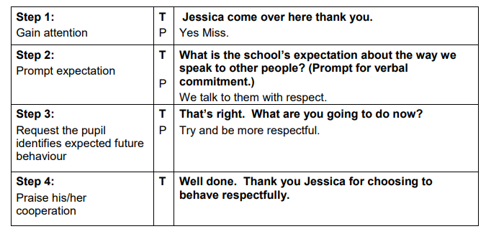

Restorative Questioning: Use the five self-reflective, restorative questions in the sequence listed below. This approach should enable the pupil who bullies to take responsibility for his/her behaviour and to undertake action(s) to promote reparation.

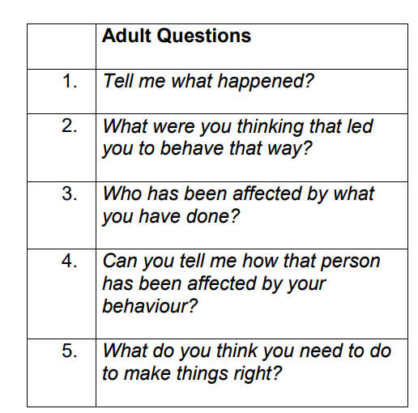

Worth a Re-Think [For Pupil Displaying Bullying Behaviour] A process for helping pupils, either individually or in small groups, to develop more appropriate responses to a range of situations through reflecting on:

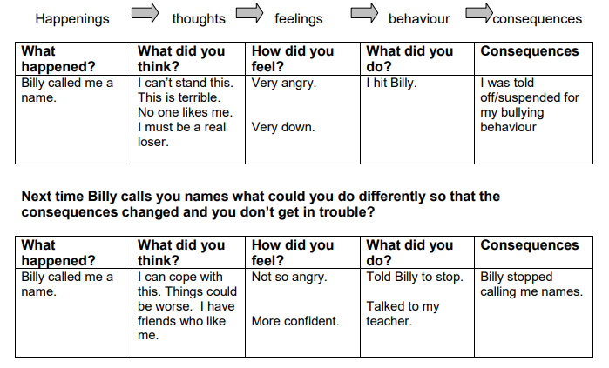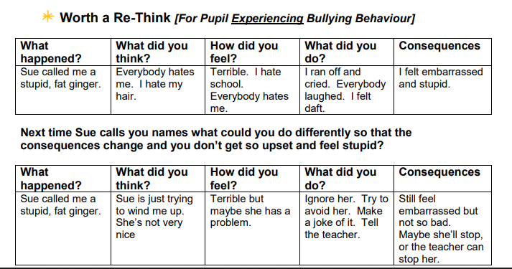

Shared Control Discussion: This structured intervention requires the pupil to choose how he/she will respond to requests to change behaviour while being made aware of the consequences his/her choice of behaviour will have.

SCENARIO 1 - Compliant pupil
Teacher notices that Jessica is verbally bullying another pupil.

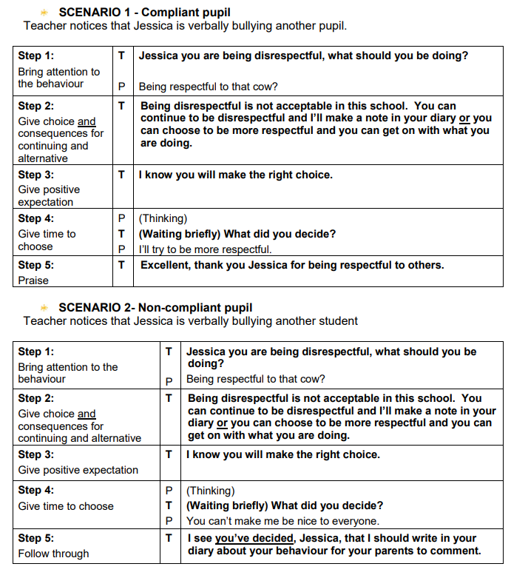

Think Time Discussion and Review Meetings:
In a one-to-one meeting the pupil who has displayed bullying behaviour may be asked to complete a ‘Think Time’ Discussion and subsequent Review Sheet (see below) to promote reparation. In some circumstances such questions may also be appropriate to use with the pupil experiencing bullying, for example if they could change something about their own behaviour which may reduce the likelihood of them being bullied. For obvious reasons this would have to be handled very sensitively. Please note - this should NOT be treated as a sanction.

Page 1: Think Time Discussion Sheet
- A pupil may be asked to complete Page 1 independently prior to meeting with a member of staff; alternatively, the pupil may be asked to complete it together with a member of staff during a one-to-one meeting.
- The information generated can be used to inform the development of a Behaviour Plan.
- Depending on age and ability individual pupils may need greater support in completing this document.
- Works best when it is used as a non-punitive intervention giving the pupil an opportunity to self-reflect on his/her behaviour in a positive way. When associated with detention it may be seen as a punishment and therefore result in negative outcomes.
- While it is unnecessary to share the specific details of the agreed actions with the target(s) it is important to reassure the target that action has been taken, that the situation will be monitored and that there is an expectation that things will improve.
- In a group bullying situation it is advisable that each pupil completes and discusses the form on an individual basis. While space has been left for up to three restorative actions less may suffice.
- If a pupil is not able to suggest an appropriate action to make things better, staff will need to offer some suggestions and ask pupils to prioritise these. It is at the discretion of the school whether or not a parent’s signature is required.

Page 2: Review Meeting Discussion Sheet
After an appropriate period of time, e.g. one week, staff and pupil meet again to review and discuss agreed action(s) and their effectiveness in resolving the situation. The current situation should be reviewed and recorded on this sheet. Future actions will depend on the outcome of the initial review.

- The monitoring process works best when assessments are based on a range of relevant perspectives which will include feedback from the pupil displaying bullying behaviour, the pupil who has been bullied, and where relevant, peers, staff, parents/carers.
- To assess the success of the actions agreed on page 1 it is useful to meet with the target beforehand to establish what if any improvement has taken place.
- To monitor the effectiveness of the agreed actions with the target use open questions such as:
  - How did things go for you today in the playground?
  - In what ways have things got better for you?

REVIEW OF OUTCOMES:
comments could include one or more of the examples below:
No further action is required at this stage.
Ongoing monitoring of the situation is necessary e.g. weekly review with all pupils involved is required. The pupil has agreed to participate in The Support Group Method – level 2/3 intervention.
A Behaviour Plan (Code of Practice) will be devised and implemented.
Parents/carers will be invited to attend meeting with appropriate member of staff/Senior Leadership Team/Pastoral Lead.

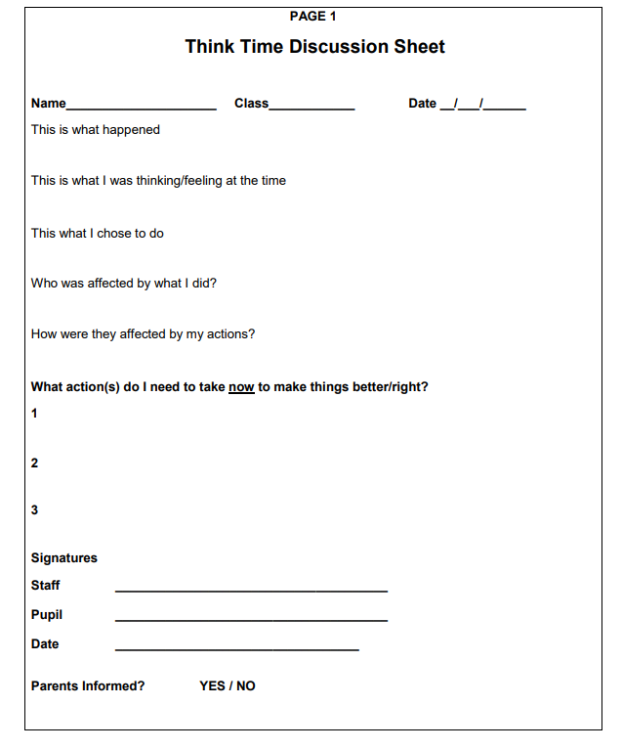

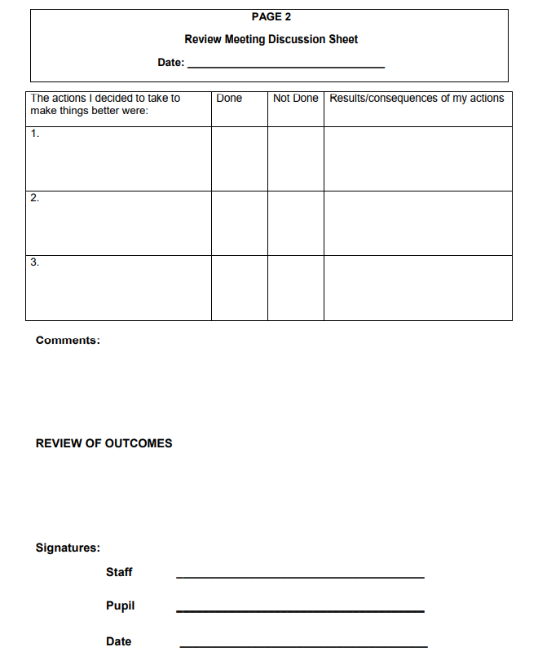

Level 2 Interventions - Intermediate Level Bullying Behaviour

Group Support Quality Circles
This problem-solving approach, advocated by Cowie and Sharp, provides pupils with a forum in which issues surrounding bullying can be addressed.

Application
The group comprising 6-8 pupils meets weekly for approximately 45 minutes. To deal with a specific problem the Quality Circle works through the following five steps:

Step 1: Determining the problem
- Pupils take turns to mind shower issues/problems arising from specific bullying behaviour.
- A ‘pass’ rule operates if a pupil does not have a contribution to make. A scribe lists the ideas on a flip chart. There is no discussion at this stage. On completion, the pupils vote to prioritise the listed items.

Step 2: Mind showering possible causes
- Pupils look for possible causes of the problem, using a series of WHY questions In the interim before the next meeting, pupils may choose to collect data by:

- Interviewing a sample of pupils
- Making observations during an agreed time slot
- Conducting a survey.

Step 3: Developing a solution

- Pupils having identified causes, explore possible solutions using a series of HOW questions to formulate an action plan. Members of the group take on three defined roles:

- The Inquirer whose role is to ask HOW questions until all possibilities are exhausted
- The Respondent whose role is to answer the questions
- The Observer whose role is to record the answers given.

- Once the entire HOW questions have been answered pupils discuss the pros and cons of each proposal and evaluate how costly and realistic each proposal is.

Step 4: Offering solutions to Senior Leadership Team (SLT) for feedback
- The group prepares a professional presentation outlining their agreed suggestions.
- The presentation is given to members of the SLT using a variety of techniques.
- Group members answer SLT questions and present arguments to justify their decisions.

Step 5: Reviewing and evaluating the solution(s) offered
- Following the presentation, the SLT decide on the suitability of the proposed solution/s.
- If adopted the SLT implements the solution/s and following evaluation meets with the group to give feedback. If the SLT chooses not to adopt the solution/s they meet with the group to discuss the matter and explain their decision.

The Support Group Method
This approach, originated by Maines and Robinson, typically addresses cases of bullying in which there is some group involvement. It is important to recognise that although no one is being blamed for the bullying, this approach challenges pupils to accept joint responsibility to improve the situation for the pupil experiencing bullying. This approach works best when:
- It is used to manage incidents of ‘low’ severity ie levels 1-2 incidents.
- Positive peer pressure is constructively channelled.

Application
There are seven steps in the approach, beginning with a meeting with the target. This is followed by holding a meeting with the group of pupils who have engaged in the bullying and a number of other pupils who can be expected to be supportive of the target. The target is not included in the group
meetings.

Step 1: Meet with the pupil experiencing bullying
- Establish the impact that the bullying has had.
- Invite him/her to provide an account of the distress experienced.
- This may be verbalised, written or drawn.
- Ask him/her to identify those involved in bullying behaviour towards them and suggest the names of people to form a group who could help solve the problem.
- Assure him/her that no one will be blamed.

Step 2: Convene a group meeting comprising 6-8 pupils
- Include those who have been identified as being involved in the bullying and those who are expected to support the pupil experiencing bullying.
- Ensure that all have consented to join the group, understand what is involved and will commit to attending required meetings.

Step 3: Explain the problem
- Explain the problem to the group and especially the distress that the target is feeling using evidence provided by him/her.
- Neither outline specific incidents nor make accusations.

Step 4: Promote shared responsibility
- Emphasise that no one is going to be blamed.
- Everyone is here to work collaboratively to solve the problem.
- Everyone has a responsibility to improve the situation.

Step 5: Ask for ideas
- Ask for suggestions as to how things may be made better for the pupil being bullied.
- Invite each member to state specifically what action he/she will take to help the him/her.

Step 6: Leave it up to them
- Give responsibility to the group expressing expectation that each will act according to his/her commitment.
- Thank each member for their support.
- Tell pupils that there will be further individual meetings with group members to see how things are going.

Step 7: Final meetings
- Meet with members individually to ascertain progress.
- Meet with pupil experiencing bullying as part of the monitoring process.
- Assess and record the intervention’s level of success.
- Review situation. If unsuccessful refer to the table of interventions to select another approach. It is not recommended that you repeat this intervention.

Solution Focussed Support Group Method
Traditional approaches to bringing about change in bullying situations are often based on a problem solving model. The Solution Focussed approach is substantially different and takes the focus away from exploring the problem or gathering detailed accounts and facts / information to analyse the concern. The focus of attention and action is on bringing about the preferred state of affairs, by exploring existing strengths and personal qualities that will further develop a solution. This allows for a quicker resolution that helps pupils to fulfil their needs without compromising the rights of others.

Problem Solving | Solution Focussed
- Identify and define the problem  - Analyse/discuss causes  - Propose remedies  - Plan Interventions  - Review | - Vision – preferred future without problem  - Identify and value existing strengths  - Suggest next steps  - Innovate  - Celebrate

Note that during a solution focussed intervention with small groups or individuals, the focus involved is not on the bullying, but on those times when it is not happening.

Application
- Quick Summary - Interview the pupil being bullied to get the names of those involved in bullying behaviour towards them, the names of bystanders and their friends.
- Convene a support group:
- Raise empathy
- Ask for suggestions
- Pass over responsibility and arrange to review.
- Review with target (2 review meetings are normally sufficient)

See below for scripts

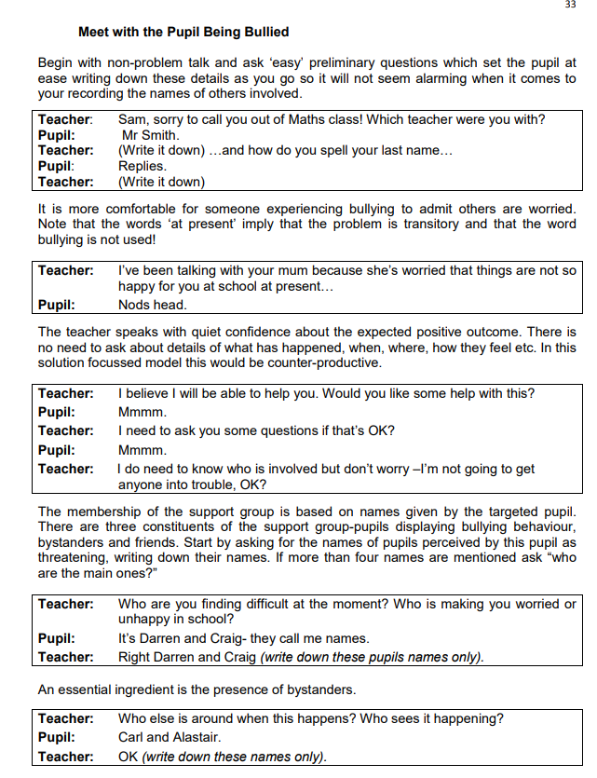

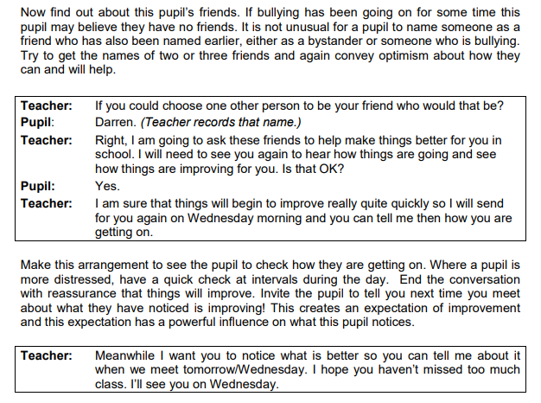

Convene the Support Group
Implement the Support Group Meeting by convening the group made up from names mentioned as causing the pupil difficulties and friends or potential friends. Explain to them that you are concerned about Sam, that they have been selected because you know they can help and that the aim for this group is to help make Sam happier in school. Do not go into detail about the bullying Sam has been experiencing and do not suggest any blame for this.

Gain their commitment and raise their empathy for this pupil by having them talk about occasions when they were unhappy in school. Ask for suggestions complementing all these and writing them down showing you accept and value these while gently guiding their actions. The essential point is that the pupils in the group make the suggestions and choose to do them rather than the teacher making suggestions about what these pupils could or should do in the future. Check that they think they can do it rather than asking them to be friends with the targeted pupil and then compliment them for their kindness. Pass over responsibility to the group and arrange to review.

Review with the Pupil Being Bullied
This can be a very short meeting in which the teacher discusses any improvements and congratulates the pupil on these changes acknowledging their role in the solution.
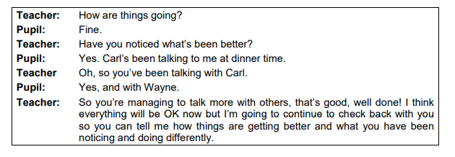

The Fogging Exercise

This script is intended to illustrate how the fogging technique can work and to guide teachers and pupils in how to respond to bullying-type behaviour such as name calling, criticising and belittling another. If used successfully, it can support pupils who are the target of bullying behaviour and strengthen them to respond to this behaviour where they begin to feel more in control and to have increased confidence.

It is important for the pupil being bullied to feel comfortable with the language and phrases used so it is acceptable to replace those used here.

In this example, A denotes a pupil displaying bullying behaviour, and B the pupil experiencing bullying behaviour.

A: You have a big nose.
B: That’s true; I do have a big nose.
A: It’s so large I think I’ll call you Pinocchio.
B: OK I like that name, Pinocchio it is.
A: You are the dumbest person in the whole school.
B: That might be true.
A: You must be really stupid to keep agreeing with me.
B: That’s true.
A: You keep saying that’s true.
B: That’s true.

The target changes tack and begins now to answer a question with a question. The idea is to confuse the pupil with this response and he/she has to explain.

A: Why are you so dumb?
B: Why do you think I’m dumb?
A: Nobody likes you.
B: That’s your opinion. Why do you think that?
A: You’re always on your own at lunch.
B: That’s true. Why does that bother you?
A: Only losers spend lunch time on their own.
B: That’s your opinion.
A: You are thick. B: It may seem like that to you.

Practice is important to become confident in using this technique.

Level 3 Intervention – Complex Bullying Behaviour

At this level, the Pastoral Lead/Head Teacher should use all available information to inform a Risk Assessment. This assessment should involve an analysis of the presenting Risk Factors and Protective Factors. This risk analysis will determine the level of risk and needs and appropriate intervention from the framework. We consider these in terms of the following:

- School Environment
- Family Environment
- Peer Environment
- Psycho-social characteristics of the individual pupil

Strength Building
It is clear that pupils who engage in repetitive and/or severe bullying behaviour require additional measures in order for their behaviour to be influenced. This is especially the case for “at risk” pupils who present with many risk factors and few protective factors.

Research shows that such pupils often have ‘delays’ in one or more of their social and emotional capabilities, as well as being disconnected from positive relationships, programmes and opportunities in their school, home and community.
Such pupils require Strength Building interventions. Individual action plans for ‘strengthening’ such pupils should focus on developing their social emotional skills and values. Responsibility for strengthening these skills can be assumed by class teachers, SENCO or Pastoral Lead and may involve support from other professionals, such as the school counsellor or external agencies.

Parents/carers will be informed of the programme, their consent obtained and wherever possible parents will be involved and contribute to this intervention, reinforcing these skills beyond the school setting.

Pupils who are functioning at a high level of wellbeing
Such pupils have higher levels of achievement and come from generally supportive school, home and community backgrounds. The plan could involve promoting their connections to positive peer role models and opportunities to collaborate with these peers in improving the wellbeing of the pupil who was targeted.

This could be achieved by using Small Group Interventions, such as The Support Group Method, the PIKAS Method of Shared Concern, restorative meetings and restorative conferences. An intervention should be restorative in orientation. The use of a behavioural contract linked to an SPP/IBP should also include social and emotional mentoring to strengthen this pupil resilience, teach conflict resolution skills and develop empathy. Intensive work with this pupil’s parents will also be required at this level.

Pupils who are functioning at lower levels of wellbeing

“Pupils who bully and feel disengaged from the school community (Eisenberg, et al, 2003), feel unsupported at home (Perren and Hornung, 2005) and possess ineffective coping strategies (Smith, 2004)”

Such pupils have few protective factors and many risk factors and consequently experience additional emotional and behavioural difficulties. They are likely to under-achieve, have poorer resilience, social skills and values, learning capabilities and have weaker connections with positive adults and programmes in their school, home, and community. Individualised, strength-building plans and strengthening connections should be developed and implemented.

It is often the case that in addition to the Pastoral Lead, other professionals from community agencies can assist in providing suggestions for connecting the pupil to the community.

PIKAS - Method of Shared Concern (Child Health Promotion Research Centre, Edith Cowan University)

The Method of Shared Concern aims to change the behaviour of pupils involved in bullying incidents and improve the situation of the pupil being bullied. The method employs a non-punitive, non-blaming and non-aggressive approach to individual and group discussion of the incidents. Each pupil involved in the bullying incident participates in a series of individual discussions with a staff member, beginning with the pupil who engaged in the bullying incident. Clearly defined steps are used to reach a point where the pupil displaying bullying behaviour agrees that the pupil being bullied is having a difficult time. The pupil is then encouraged to suggest and try out ways of helping to improve the situation for pupil being bullied. The pupil being bullied is also provided with the opportunity to discuss the incident and encouraged to consider ways in which they can improve their own situation.

This method of managing bullying incidents is based on the following principles:
- Bullying occurs in a group context.
- Changing the social dynamics that maintain bullying will prevent further bullying incidents.
- Promoting a shift in behaviour by encouraging empathy and concern for others.
- Punitive measures model and reinforce the use of power to meet needs and wants and put students at risk of revenge

Application of PIKAS Method of Shared Concern

Pupils who have engaged in bullying behaviours are assisted through individual and group meetings. The PIKAS Method of Shared concern is more complex than the Support Group Method, and involves a number of stages.

- The pupil(s) displaying bullying behaviours are interviewed individually Pupils who have been identified as being involved in the bullying of a fellow pupil are interviewed individually, starting with the person who is thought to most closely fill the role of ‘ringleader’. The member of staff explains that the purpose of this meeting is to discuss the distressing situation of the pupil who has been harmed or upset in some way. It is important that no accusations are made, simply that there is an acknowledgement that the target is experiencing distress. When there is this acknowledgement from the pupil being interviewed the staff member invites the pupil to suggest how the situation can be improved. Suggestions are reinforced and arrangements are made to meet again to ascertain progress. This process is repeated with each pupil involved. See sample script below.

- Meeting with the pupil being bullied Only after each pupil involved has been interviewed does the member of staff arrange to meet with the target. In talking with him or her, the member of staff discovers more about the situation and explores the dynamics involved. This may, to some extent, include exploring the possibility that they may have acted so as to provoke the bullying behaviour. Importantly, this is not viewed as an excuse for the bullying behaviour, and the he/she is never blamed for provoking the behaviour. The member of staff explains that in conversation with the individual pupils there was a readiness on their part to help resolve the problem. See sample script.

- Follow up individual meeting with pupils involved in bullying behaviour In individual meetings with these pupils, the member of staff asks about actions that have been undertaken to improve the situation.

- Meeting with pupils displaying bullying behaviours as a group As soon as there is evidence of progress a meeting is convened with the identified group. They are congratulated on the positive things they have done and asked what could be done next. The member of staff leads the group to a point where it is appropriate to consider inviting the target to join them, to reach a solution. Pupils must be carefully prepared for this meeting. They are required to indicate what they are prepared to say and agree to as part of this. If they believe that concessions are needed from the target (if they believe he/she has acted to provoke the bullying behaviour) a plan is drawn up by the group members to handle the situation.

- The target is invited to join the group The pupil being bullied is duly invited to join the group and – if necessary – prepared for the meeting. This could include discussing how he/she might respond to what the pupils in the group might have to say.

- Final meeting with the all pupils involved This meeting provides an opportunity for the identified pupils to resolve their differences. In some cases a mediated solution may be brought forward. To reduce the chances of any recurrence of the problem, the participants may be asked to draw up an agreement or contract stating what they have undertaken to do

The assumptions underlying the PIKAS – Method of Shared Concern are:

- In cases of group bullying it is better to begin with meetings with pupils individually rather than as a group. In part this is because working with a group tends to be difficult in bullying situations. It is often possible to connect with pupils as individuals and gain their acknowledgement that the pupil being bullied is distressed and needs to be helped.
- As individual pupils who have bullied someone are much more likely to feel empathy for the target and to offer to help if they are not in a group. Some, at least, may come to want to see the problem solved, so that they no longer feel any responsibility for an enduring distressing situation.
- Some pupils that experience bullying are provocative (a minority) and this need to be explored. However, it is important that this is never seen as an acceptable excuse for bullying behaviour, and that these pupils never blamed for the bullying behaviour. This may require mediation before any solution is possible.
- Enduring solutions to bullying behaviours are much more likely when the pupils displaying bullying behaviours as a group have agreed to a course of action that will result in all pupils being safe

Steps for ‘Method of Shared Concern’ MODEL A - Meeting with a child who has been displaying bullying behaviour

Step 1 “I have asked you to come and speak with me because I have heard that some bad things have been happening to ‘x’ that are making him/her very unhappy at school.”

- Wait for the child to respond. If the student doesn’t respond ask, “Do you know anything about this that might help me?”
- Do not try to force the child to ‘own up’ or admit to his/her involvement, simply to acknowledge that there is a situation which is making x unhappy.
- If the child complains about x, don’t question; just let the child explain their situation.

Step 2 “So it sounds like x is having a bit of a tough time.”
- Wait for the child to respond.
- As soon as the child agrees and acknowledges that x is having a bad time and is unhappy move to Step 3.
- If the child says that x is to blame, accept the point but suggest that x is still having a bad time and is unhappy.

Step 3 “Well I was wondering what you could do to help to improve the situation for x to help him/her to become happier at school.”
- Accept any suggestions with positive feedback.
- Don’t question their suggestions if they are positive.
- If the suggestions are negative, ask the student whether they think this would help x to feel happier.
- If the student can’t think of anything to do or is resistant to the idea, ask him/her to take some time to think about something they could do to help make x feel happier then move to Step 4.

Step 4 “OK. I’ll see you next week to find out how you are getting on.”
- If the child had an idea, then you will say you will see them to “discuss how their idea went when they tried it.”
- If they didn’t have an idea, then say you will see them to “discuss the idea they have come up with.”

Steps for ‘Method of Shared Concern’ MODEL B - Meeting with the child who has been experiencing bullying

Step 1 “I have asked you to come and speak with me because I have heard that some bad things have been happening to you that are making you very unhappy at school.”
- Wait for the child to respond. Let the child explain their situation.
- Then simply acknowledge that there is a situation, which is making him/her unhappy.

Step 2 “So it sounds like you are having a bit of a tough time.”
- Wait for the child to respond.
- As soon as the child agrees and acknowledges go to Step 3.

Step 3 (a) “I have spoken to a few students about your situation and they have made a few good suggestions to help you to feel happier and safer at school.”
- If the pupil is concerned about this reassure him/her that you will be keeping a close eye on what is happening.
- Let the pupil know that there may be a few changes in the behaviour of some other pupils towards him/her.
- If you feel the child could help the situation by changing some of his/her behaviour go to Step 3(b).

Step 3 (b) “I was wondering what you could do to help to improve the situation for yourself to help you to become happier at school.”
- Accept any suggestions with positive feedback.
- Don’t question their suggestions if they are positive.
- If the suggestions are negative, ask the student whether they think this would help him/her to feel happier.
- If the student can’t think of anything to do or is resistant to the idea, ask him/her to take some time to think about something he/she could do to help to feel happier then move to Step 4.

Step 4 “OK. I’ll see you next week to find out how you are getting on.”
- If the child had an idea, then you will say you will see them to “discuss how their idea went when they tried it.”
- If they didn’t have an idea, then say you will see them to “discuss the idea they have come up with.”

Level 4 Interventions – High Risk Bullying Behaviour

Bullying behaviours assessed as Level 4 are severe and involve a significant threat to the safety and welfare of any or all of the pupils involved. Such severe bullying concerns may be new or may have proved resistant to earlier school interventions and have now been assessed as high risk. Incidents at this level must be assessed in relation to the risk posed to any/all of the pupils involved. As such, the school’s Safeguarding and Child Protection Procedures will need to be invoked.

School’s Pastoral Lead, Senior Leads, DSLs and Head Teacher will need to liaise with, pupils, their parents and work together in partnership with a range of external professionals and agencies to develop an inter-agency risk management and/or safeguarding plan. This may incorporate intensive support services to the pupils involved and their families. Appropriate staff with specific responsibly, such as SENCO, DSL, Designated Teacher for LAC/Post-LAC should be involved where concerns are of this level.

Schools should respond to pupils’ needs and presenting risk, consistent with the SEN Code of Practice.

In some circumstances, parents/carers may be experiencing their own challenges which contribute to their child’s behaviour in school or their capacity to engage and contribute to the strengthening programme.

Referral to inter and multi-agency liaison and integrated working with other external agencies is required at this stage.

